Project Design Phase
Solution Architecture

Date | 01 October, 2026
Team ID | 6ab7ec71d083b0e2ee72a0a3
Project Name | Script-Controlled ACL – Restrict Record Access Based on Field Value
Maximum Marks | 4 Marks

Solution Architecture:
The solution architecture defines how ServiceNow controls record access using script-controlled Access Control Lists (ACLs). The system authenticates users, validates their roles, and evaluates record field values through ACL scripts. Based on these conditions, access is allowed or denied for READ, WRITE, CREATE, and DELETE operations. The solution provides secure and controlled access to sensitive ServiceNow records.

Example - Solution Architecture Diagram:
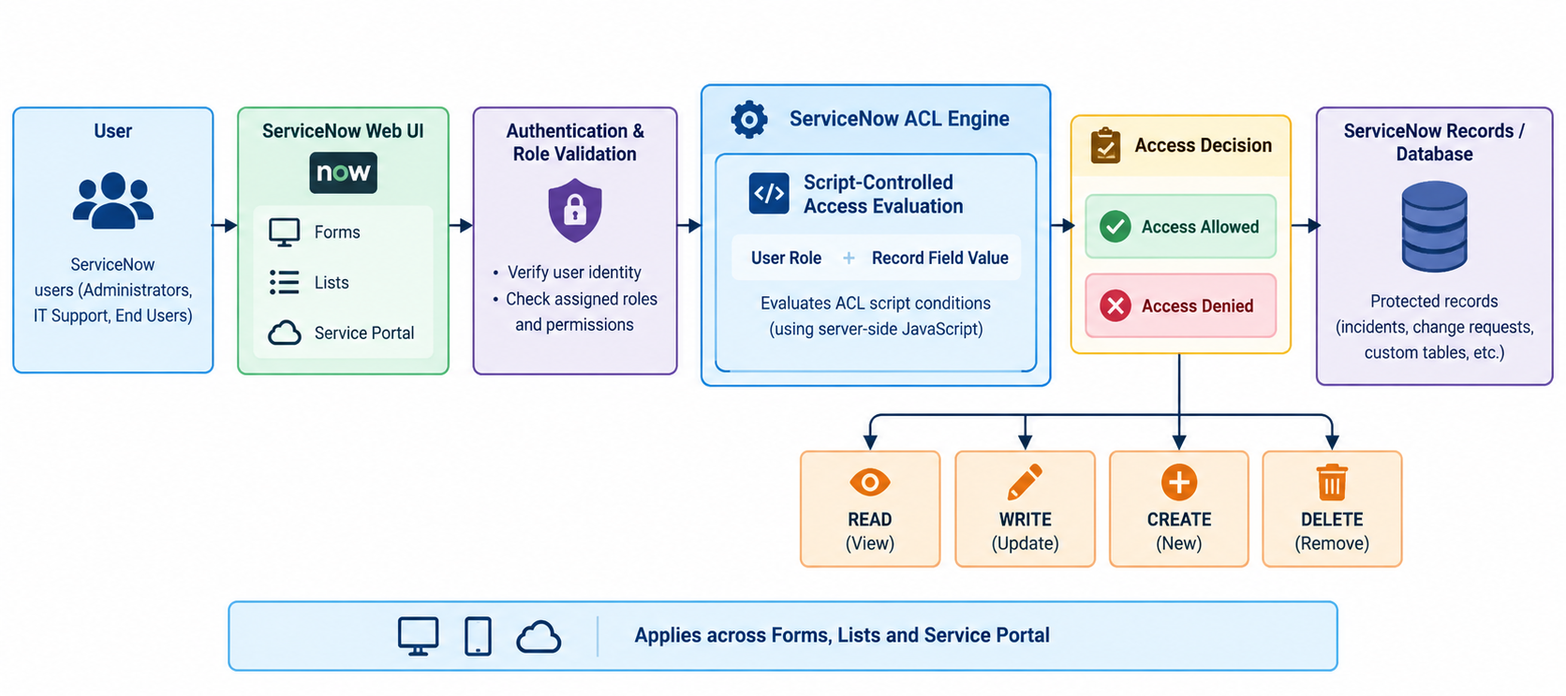

Architecture and access-control flow of the Script-Controlled ACL solution

Reference:
ServiceNow Documentation – Access Control Lists (ACLs)
https://www.servicenow.com/docs/bundle/yokohama-platform-security/page/administer/security/concept/c_AccessControlListRules.html

